|  |  |
| --- | --- |
|  |  |

EPTF CLL Rendezvous, User Guide

Contents

1 Introduction 2

1.1 Revision history 2

1.2 About this Document 2

1.2.1 How to Read this Document 2

1.2.2 References 2

1.2.3 Abbreviations 3

1.2.4 Terminology 3

1.3 System Requirements 3

2 EPTF Rendezvous 3

2.1 Overview 3

2.2 Supported rendezvous types 4

2.3 Description of files in this feature 5

2.4 Description of required files from other features 5

2.5 Installation 6

2.6 Configuration 6

3 Error messages 6

4 Warning messages 6

5 Examples 7

5.1 Demo Module 7

# Introduction

## Revision history

|  |  |  |  |
| --- | --- | --- | --- |
| Date | Rev | Characteristics | Prepared |
| 2008-01-18 | PA1 | First draft version | EBENMOL |
| 2008-01-29 | PA2 | Updated after review | EBENMOL |
| 2009-06-08 | PB1 | New rendezvous type | EZSOSZA |
|  |  |  |  |

## About this Document

### How to Read this Document

This is the User Guide for the EPTF Rendezvous of the Ericsson Performance Test Framework (TitanSim), Core Load Library (CLL). TitanSim CLL is developed for the TTCN-3 ‎[1] Toolset with TITAN ‎[2]. This document should be read together with the Function Description of the EPTF Logging feature ‎[6]. For more information on the TitanSim CLL please consult the Product Revision Information ‎[3], the Users Guide ‎[4] and the Function Specification ‎[5] of the TitanSim.

### References

1. ETSI ES 201 873-1 v3.2.1 (2007-02)  
   The Testing and Test Control Notation version 3. Part 1: Core Language
2. 1/198 17-CRL 113 200 Uen  
   User Guide for the TITAN TTCN-3 Test Executor
3. 109 21-CNL 113 512-2 Uen   
   TitanSim CLL for TTCN-3 toolset with TITAN, Product Revision Information
4. 155 17-CNL 113 512 Uen   
   TitanSim CLL for TTCN-3 toolset with TITAN, Function Specification
5. 198 17-CNL 113 512 Uen  
   TitanSim CLL for TTCN-3 toolset with TITAN, User Guide
6. 23/155 16-CNL 113 512  
   EPTF CLL EPTF Rendezvous, Function Description
7. TitanSim CLL for TTCN-3 toolset with TITAN, Reference Guide  
   <http://ttcn.ericsson.se/products/libraries.shtml>

### Abbreviations

CLL Core Load Library

EPTF Ericsson Load Test Framework, formerly TITAN Load Test Framework

TitanSim Ericsson Load Test Framework, formerly TITAN Load Test Framework

TTCN-3 Testing and Test Control Notation version 3 ‎[1]

### Terminology

*TitanSim Core (Load) Library(CLL)* is that part of the TitanSim software that is totally project independent. (I.e., which is not protocol-, or application-dependent). The TitanSim CLL is to be supplied and supported by the TCC organization. Any TitanSim CLL development is to be funded centrally by Ericsson

*Rendezvous service* provides a generic solution for synchronization among/between various entities either locally and remotely with the help of a server component.

## System Requirements

In order to use the EPTF Rendezvous feature the system requirements listed in TitanSim CLL User Guide ‎[5] should be fulfilled.

# EPTF Rendezvous

## Overview

The EPTF CLL Rendezvous component is a fundamental component providing *Rendezvous service* for other entities. Rendezvous service is a generic solution for synchronization among/between various entities either locally and remotely.

The feature provides a server component which stores the rendezvous requests. Clients can send initial rendezvous requests of specific rendezvous types to this server. Upon receiving the requests the server checks whether the rendezvous service of the given type exists. If not, then it creates the rendezvous service instance. If the given type exists, then the server notifies the requestors with a rendezvous response. (Figure 1.)

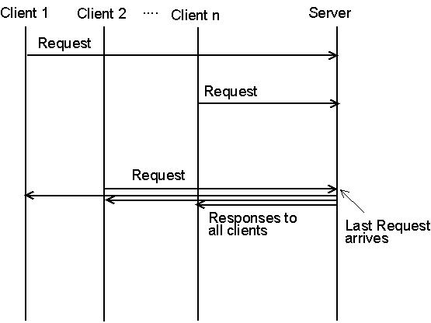

Figure 1. A typical Rendezvous service

In the State-Trigger type of Rendezvous, the clients subscribe for a an ID, and when it is triggered by one of the Clients, all the others subscribed will be notified. See Figure 2

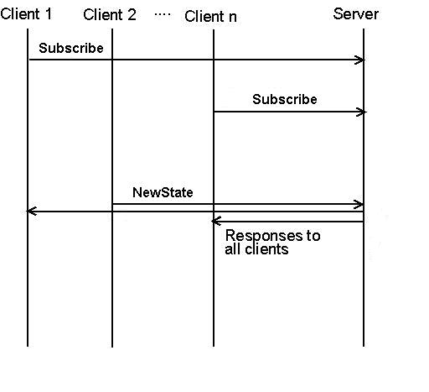

Figure 2 StateTrigger type Rendezvous

To be able to use EPTF Rendezvous, the user should extend one EPTF_Rendezvous_CT component and every user components should extend an EPTF_RendezvousClient_CT. Their init functions must be run. After initialization several rendezvous types can be started.

## Supported rendezvous types

Supported rendezvous types are:

* “Wait For A Trigger” type rendezvous. The rendezvous ID is an integer number. There are two requestors. The success trigger is to receive the requests from the two requestors. Upon receiving the requests, the server notifies the requestors with a rendezvous response.
* “Wait For N Trigger” type rendezvous. The rendezvous ID is an integer number. There are N requestors. The success trigger is to receive request from all of the requestors. Upon receiving all the requests, the server notifies the requestors with a rendezvous response.
* “State Trigger” type rendezvous. The rendezvous ID is a charstring in this type of rendezvous. There is unlimited number of requestors, who subscribes for a rendezvous ID. The success trigger is a State Change from a Rendezvous Client to that particular rendezvous ID. At that event, the clients subscribed will execute a pre-defined call-back function specified at the subscription note.

## Description of files in this feature

The EPTF CLL Rendezvous API includes the following files:

* EPTF Rendezvous
  + EPTF_CLL_Rendezvous_Definitions.ttcnpp: This TTCN-3 module contains common type definitions that should be used in all EPTF Rendezvous Components.
  + EPTF_CLL_Rendezvous_Functions.ttcn: This TTCN-3 module contains the implementation of EPTF Rendezvous server functions.
  + EPTF_CLL_RendezvousClient_Functions.ttcn: This TTCN-3 module contains the implementation of EPTF Rendezvous client functions.

## Description of required files from other features

The EPTF Rendezvous feature is part of the TitanSim EPTF Core Load Library (CLL). It relies on several features of the CLL. To use the EPTF Rendezvous, the user has to obtain the respective files from the following features:

* Common
* Base
* HashMap
* FreeBusyQueue
* Semaphore
* Logging

## Installation

Since EPTF_CLL_ Rendezvous is used as a part of the TTCN-3 test environment this requires TTCN-3 Test Executor to be installed before any operation of these functions. For more details on the installation of TTCN-3 Test Executor see the relevant section of ‎[2].

If not otherwise noted in the respective sections, the following are needed to use EPTF_CLL_Rendezvous

* Copy the files listed in section [‎2.4] to the directory of the test suite or create symbolic links to them.
* Import the Rendezvous demo or write your own application using EPTF Rendezvous
* Create Makefile or modify the existing one. For more details see the relevant section of ‎[2].
* Edit the config file according to your needs, see following section [‎2.6].

## Configuration

The executable test program behaviour is determined via the run-time configuration file. This is a simple text file, which contains various sections. The usual suffix of configuration files is .cfg. For further information on the configuration file see ‎[2].

This EPTF Rendezvous feature doesn’t define module parameters.

# Error messages

Please note, that error messages shown in ‎[2] or those of other used features or product may also appear.

# Warning messages

Please note, that warning messages shown in ‎[2] or those of other used features or product may also appear.

**Unexpected message has arrived from sender, discarded**

An unexpected message has been arrived to the EPTF Rendezvous port, which cannot be processed. The message will be discarded.

# Examples

The “demo” directory of the deliverable contains the following examples:

* EPTF_ Rendezvous_Demo.ttcn

## Demo Module

The demo module (EPTF_ Rendezvous_Demo.ttcn) illustrates a typical usage of the EPTF Rendezvous feature.

Starting a “Wait For A Trigger” type rendezvous:

function f_RendezvousClient_Behaviour(in charstring pl_selfName, in EPTF_Rendezvous_CT pl_server) runs on Client_CT{

f_EPTF_RendezvousClient_init_CT(pl_selfName,pl_server);

var integer vl_Idx;

vl_Idx:=f_EPTF_RendezvousClient_WaitForATrigger(100);

if(f_EPTF_RendezvousClient_WaitForResponse(vl_Idx))

{

log("---Trigger received---");

}

setverdict(pass);

f_EPTF_Base_cleanup_CT();

}

Starting a “Wait For N Trigger” type rendezvous:

function f_RendezvousClient_Behaviour(in charstring pl_selfName, in EPTF_Rendezvous_CT pl_server) runs on Client_CT{

f_EPTF_RendezvousClient_init_CT(pl_selfName,pl_server);

var integer vl_Idx;

vl_Idx:=f_EPTF_RendezvousClient_WaitForNTrigger(100,3);

// rendezvous ID=100, number of requestors=3

if(f_EPTF_RendezvousClient_WaitForResponse(vl_Idx))

{

log("---Trigger received---");

}

setverdict(pass);

f_EPTF_Base_cleanup_CT();

}